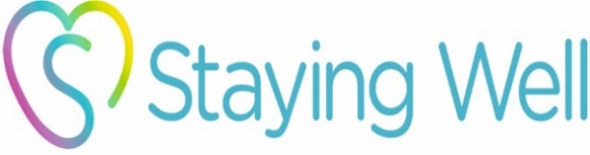
Staying Well Isolation Fund
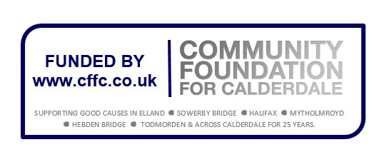
Terms and Conditions

These are the rules that you have to keep to if you receive funds through this scheme. Please make sure you read these rules carefully before signing the grant acceptance form.

- This grant is awarded to you based on the information you provided to us in the application form and in any subsequent correspondence or discussions.
- You must complete a monitoring form and send it back to the Sowerby Bridge Staying Well Steering Group within one month of the grant being spent.
- The grant must be spent within 12 months of the award being made.
- You must use the grant for the purpose it is awarded, as set out in the notification letter. This grant must not be used for any other purpose without prior permission.
- You must inform the Sowerby Bridge Staying Well Steering Group as soon as possible of anything that might affect the grant, and how it is used.
- You must keep records showing how you have spent the money, including all receipts or invoices to be returned with the monitoring form.
- You must make sure that you keep records so that you can answer all of the questions on the monitoring form, including the one asking for number of people benefiting.
- You must comply with any relevant laws and regulations, including health and safety rules, minimum wage requirements and the Equality Act 2010.
- You must make sure that you have any necessary permits, licences and insurance for all activities linked with the grant.
- The Sowerby Bridge Staying Well Steering Group has the right to claim back any overpayment of grant, and any underspend must be returned.
- You will have to repay the grant if:
  - You use the grant for any purpose other than set out in the confirmation letter without getting our permission first
  - You break any of the rules set out here, including the need to return monitoring information to us
  - Any significant information you gave in the application process was false.
- Priority will be given to local community groups running small local projects.
- Any publicity of events or activities funded though the Staying Well Isolation Fund should use the official Staying Well branding along with the Community Foundation for Calderdale (CFFC) branding. These will be provided to you by the Sowerby Bridge Staying Well Steering Group.

